
LAB REPORT 07
Data Communication & Computer Networks


Submitted To:
Engineer Shehzad Malik
Submitted By:
Sumama Rahim
F24BSCS039
BS CS (F24-A-Morning)
Date: 12/13/2025
LAB REPORT – 07
Cisco Packet Tracer – Dynamic Routing – OSPF Single Area

Problem:
Make 3 router topology and do network advertised missing IPs dynamically.
Solution:
Required Resources:
- 3 Routers
- Serial 0/0 interface, Serial 0/1
Topology

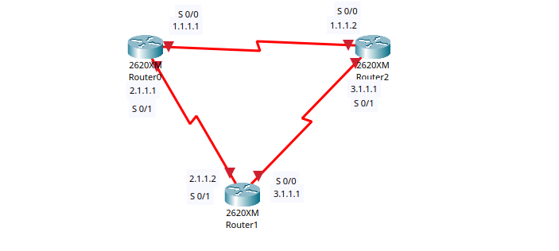
NOTE:
Addresses:
Network 1 (Router 1 and Router 2): S 0/0 1.1.1.1 and 1.1.1.2 (Via serial DCE cable)
Network 2 (Router 1 and Router 3): S 0/1 2.1.1.1 and 2.1.1.2 (Via serial DCE cable)
Network 3 (Router 2 and Router 3): S 0/0 3.1.1.1 and 3.1.1.1 (Via serial DCE cable)

Hardware Setup:
To enter serial interface, first we need to switch OFF of all routers and insert WIC-2T card in it and then switch ON.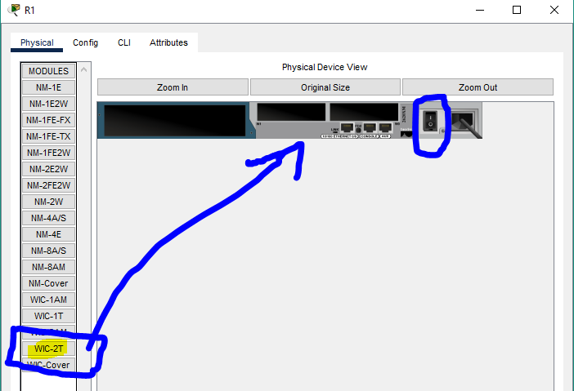

It should be inserted like this
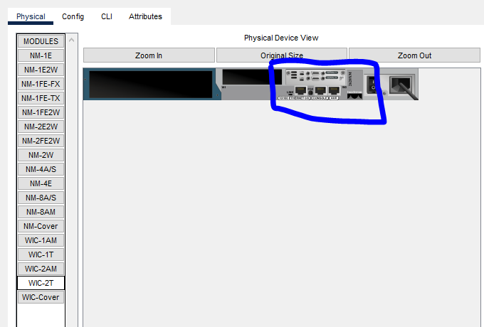

Task 1: Setting up IP addresses
For Router0 (Serial 0/0, Serial 0/1)
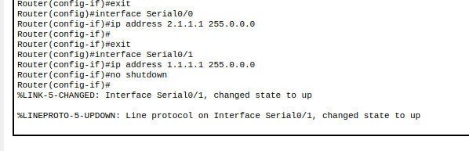
For Router1 (Serial 0/0 and Serial 0/1)

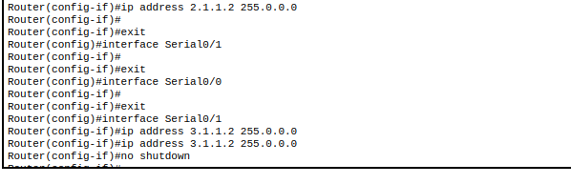
For Router2 (Serial 0/0 and Serial 0/1)

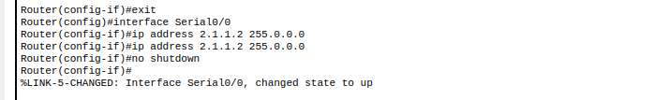
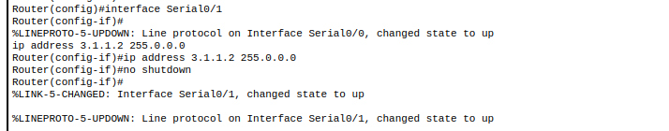

NOTE: Now all links are up. But there is a lot of IP addresses are missing, we need to assign it.
Now, so we need to advertising the missing IPs – dynamically using OSPF Multiple Area
On Router0 we have following connection

So connected networks are 1.0.0.0 and 2.0.0.0
Let’s advertise missing networks

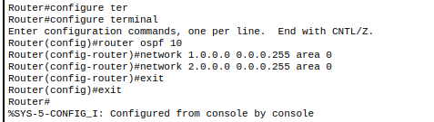
To check

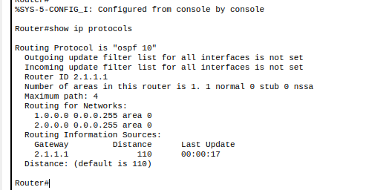
On Router1
So connected networks are 1.0.0.0 and 3.0.0.0
Let’s advertise missing networks

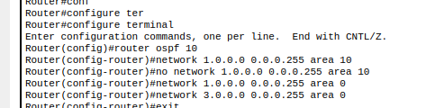

To check
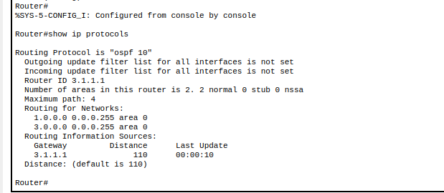
On Router2
So connected networks are 1.0.0.0 and 3.0.0.0
Let’s advertise missing networks
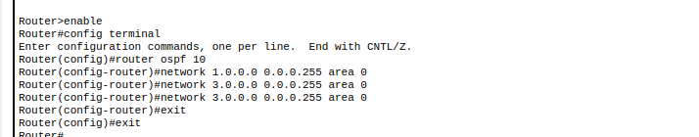

To check

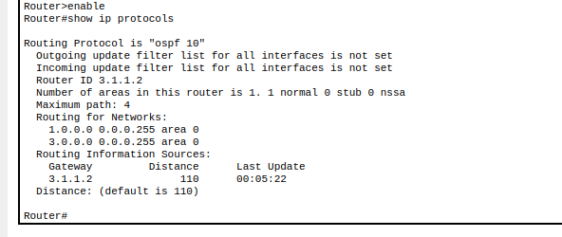

NOTE: we use wildcards instead of subnet masking. (Which is opposite to subnet masking – ON parts will be OFF and vice versa.).

The End

